How to use Sleep_Micro_Waves Toolbox

Check that you're in the folder that contains the toolbox, or that the path to the folder has been added to Matlab paths.

From the Matlab command window, type:
>> Sleep_Micro_Waves

This will launch the main toolbox window with the possibility to launch one of the three main modules:

1) Visual Detection
2) Automatic Detection
3) Visual Correction

The basic principles of how to use each one of these modules will be described below.

1) Visual Detection
-----------------------------------

-To load data go to the menu: File\Load EEG Data and select the file to import

e.g. test_data.mat

(If the data file contains more than one channel, you will be asked to choose one channel index)
the following message box will shown wen select data file :

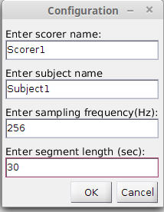

After entering specified informations , press OK to open the ''visual_scoring'' interface

To perform visual scoring
1. Delimit the event to score using two lines : blue and red
2. Select the event type using radio buttons (on ''Select event'' panel)
3. Press Validate button to save results in the specified file (scorer name_subject name_kcomplex.txt or scorer name_subject name_spindles.txt)
4. Move to the next (previous) segment using next (previous) button or go to a desired segment, taped in the text box, using goto button

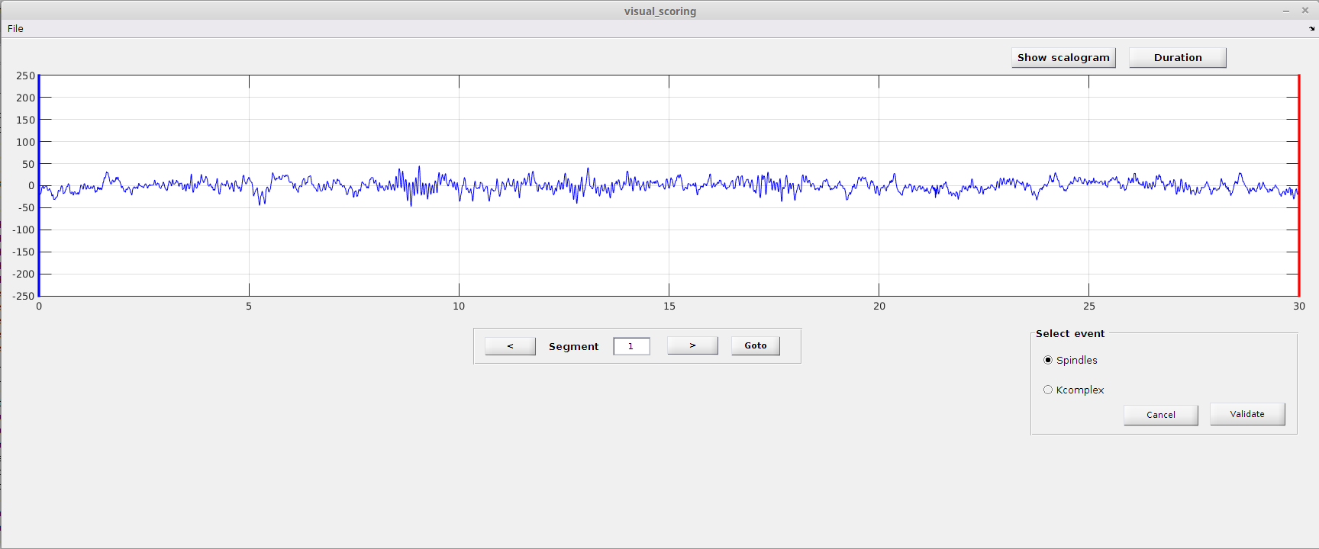
Note:

1) text files will be saved in the Matlab current directory.

2) Cancel button allows cancel only the last marked event.

3) Duration button is used to compute the duration of an event delimited by the two lines.

4) Show Scalogram button compute and display the Time frequency map of the current segment

2) Automatic Detection
-----------------------------------

i. Find the main Sleep_Micro_Waves window and select "Automatic Detection", this will close the Visual Detection window if it was open.

ii. Load data on which you wish to detect spindles and/or K-complex events. To do this, go to the menu: File\Load EEG Data and select the file to import

e.g. test_data.mat

(If the data file contains more than one channel, you will be asked to choose one channel index)

iii. Select detection mode from the list menu (upper right corner)

a) If you already know the thresholds you want to use (for example based on previous training) you can choose the "Enter thresholds and run detection"
Example values for the Kcomplex and spindle values are -50 and 200, but these values can change a lot depending on your data.
Example
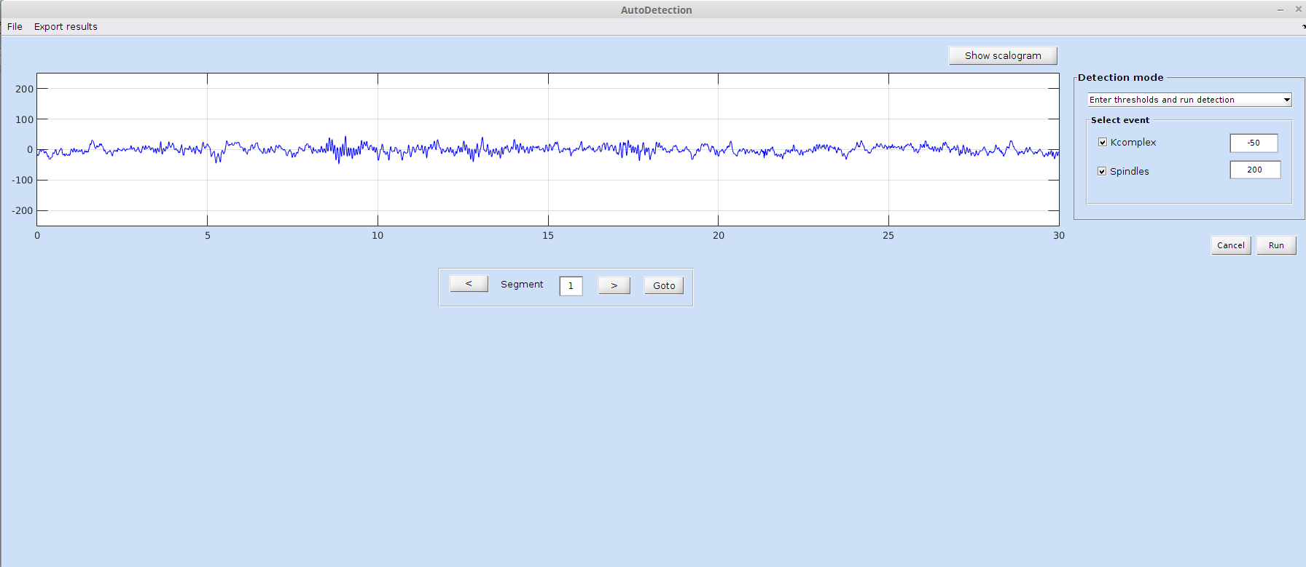
b) If you wish to use the data as training to identify the best threshold values, select "Compute thresholds and run detection". This will require that you then indicate which training files to use for spindles and/or K-complex events and which visual scoring files to use for each.

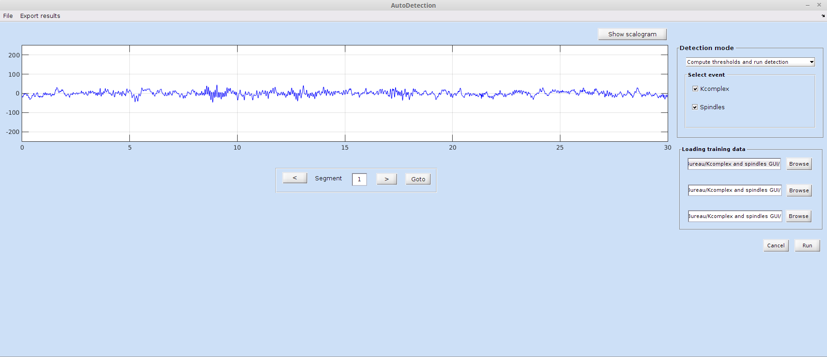

Important:
- The visual scoring file should either be the output of the Visual Scoring module, or a text file in the exact same format (see appendix A).
- Note that training procedure can take several minutes, depending on the size and sampling rate of the training data.
- The results of the detection in this module are automatically saved in separate txt files (see Appendix B for the format)

OPTIONAL:
After the detection is complete, you can compute statistics on the detected events for the whole data sets (all epochs) by clicking on the menu button Export results. This function will compute statistics and save them to a .txt or .mat file.
The currently available statistics are:
- K-complex: Total_number, Density, Frequency,Mean_amplitude,
- Spindles:Total_number, Density, Mean_duration, Frequency,Mean_amplitude,

3) Visual Correction

This module allows to correct automatic detection scores provided by the previous interface

i. Load data on which you wish to correct spindles and/or K-complex automatic detection . To do this, go to the menu: File\Load data and select the file to import

e.g. test_data.mat

(If the data file contains more than one channel, you will be asked to choose one channel index

ii. The visual correction interface allows two type of corrections:
- False negative corrections : add event that the automatic detector missed
- False positive detection: delete events has detected but the corrector don't agree
iii. Load Kcomplex and or Spindles automatic scores (the .txt file provided by automatic detection module)
you will be asked if even it is your first correction or not: if you answer 'Yes' a new file called 'automatic_score_kcomplex_corrected_by_experty.txt' will be used to save corrected scores, otherwise corrected scores will be saved in the same txt file previously loaded
False postive correction
once the Kcomplex and /or Spindles score is loaded, a Delete event panel will appear in the down/rigth corner.
To delete a false positive detection
1. Click on edit button, a new interface will be shown
2. Select the event you wish to delete (select corresponding checkbox)
3. Press delete button
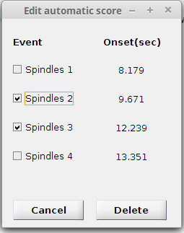

False negative correction
To add Kcomplex events missed by the automatic detector you should:
1. Select Kcomplex on the add event panel
2. Move the red line to the desired position
3. Press add button.

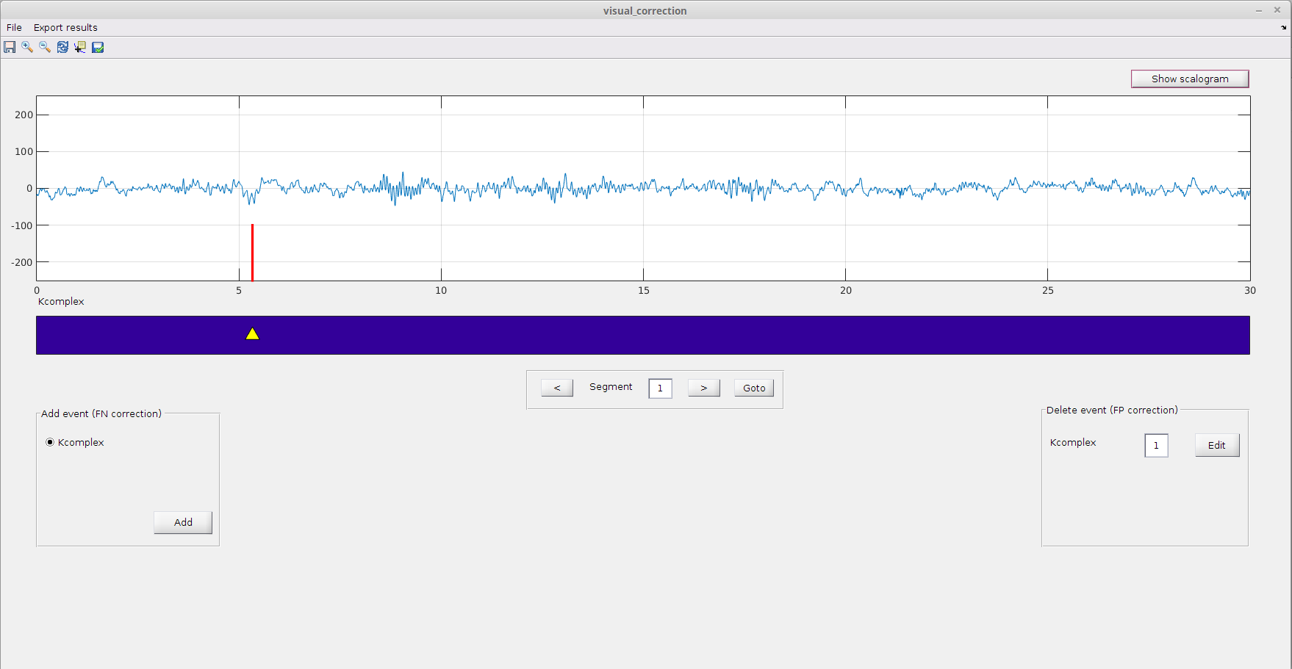

To add Spindles events
1. Select Spindles on the add event panel
2. Move the blue and black lines to delimit the event you wish to add
3. Press add button.

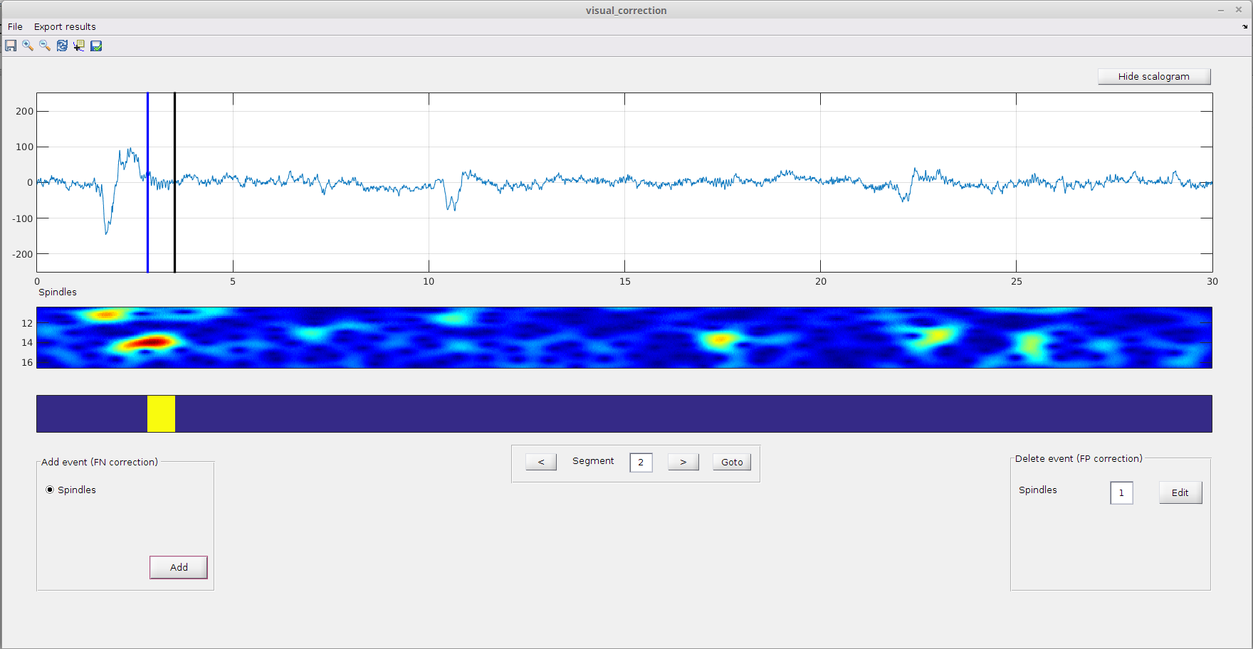
Important:
- To save modification you made, you should even click on save icon in the toolbar menu (this will save in a .txt file modification you made in the current segment) , or press auto save button in the same toolbar (modifications will be saved automatically when clicking on next button).
- The reset button on the toolbar menu allows to reload the first score any modifications made on the the current segment will be discarded.
Appendix A:

How to manually create a text file with the visual scoring information that is compatible with the detection module
Segment Onset time(sec) Offset time(sec)
1 8.4 9.54
1 12.41 12.94
2 2.16 3.53
2 17.10 17.83
2 21.3234 21.83

Appendix B:

Spindles automatic detection results text file format
Segment | number of detected spindles | 1stspindle onset time | 1st spindle offset time | 2nd spindle onset time | 2nd spindle offset time

1 2 8.18 9.67 12.24 13.35
2 0

Kcomplex automatic detection results text file format

Segment | number of detected spindles | 1st Kcomplex onset time | 2nd Kcomplex offset time
1 0
2 2 1.82 10.71

